TEXT and IMAGE Plagiarism Detection
We are using below text corpus to build plagiarism detection model and if any suspicious file data falls in similarity of this corpus then plagiarism will be detected. This corpus you can see inside ‘corpus-20090418’ folder
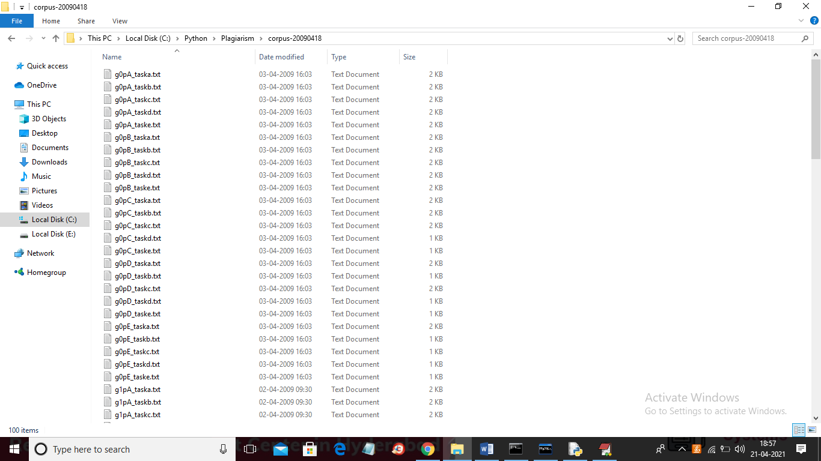
We are using below images to build histogram model and if any suspicious image similarity finds with this histogram then plagiarism will be detected. See below images used to build histogram model
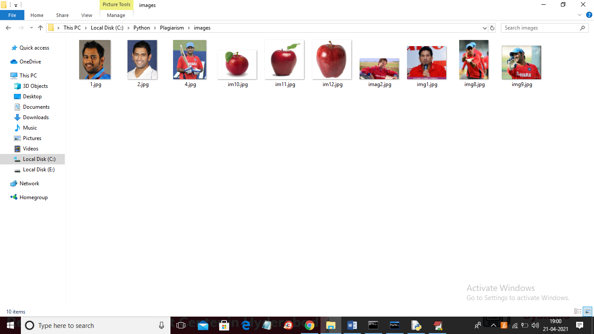
Above images are available inside “images” folder
SCREEN SHOTS
To run project install python 3.7 and then install DJANGO server and deploy code on that server and run from browser to get below screen
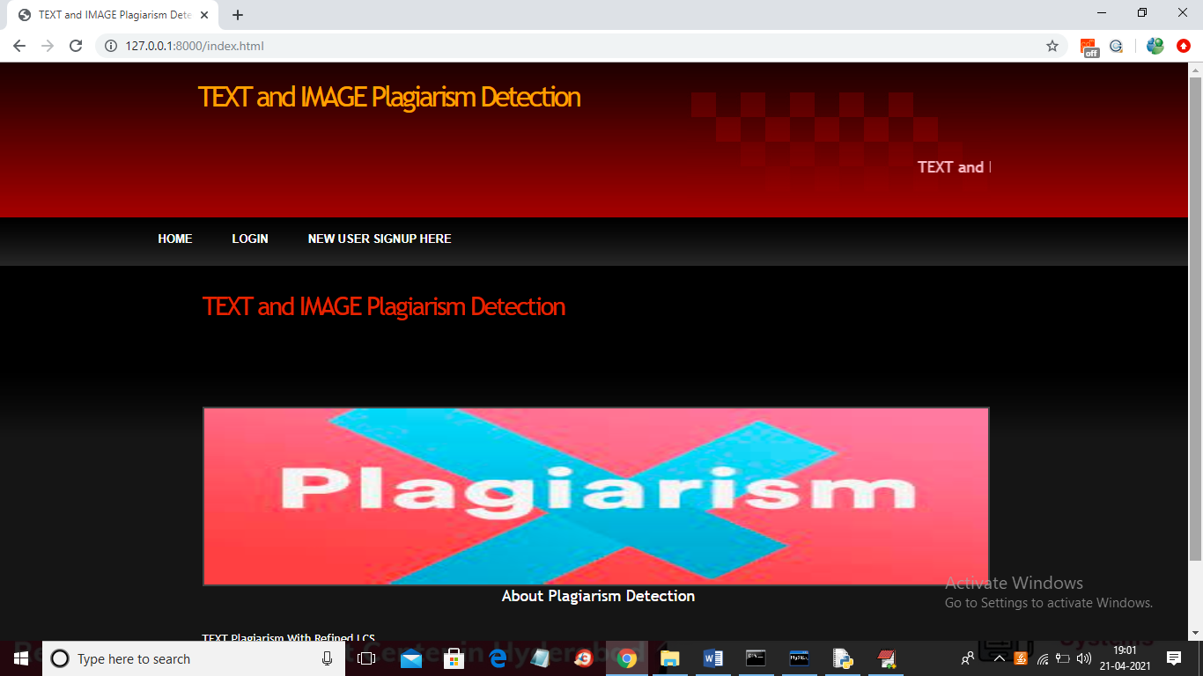
In above screen click on ‘New User Signup Here’ link to get below screen
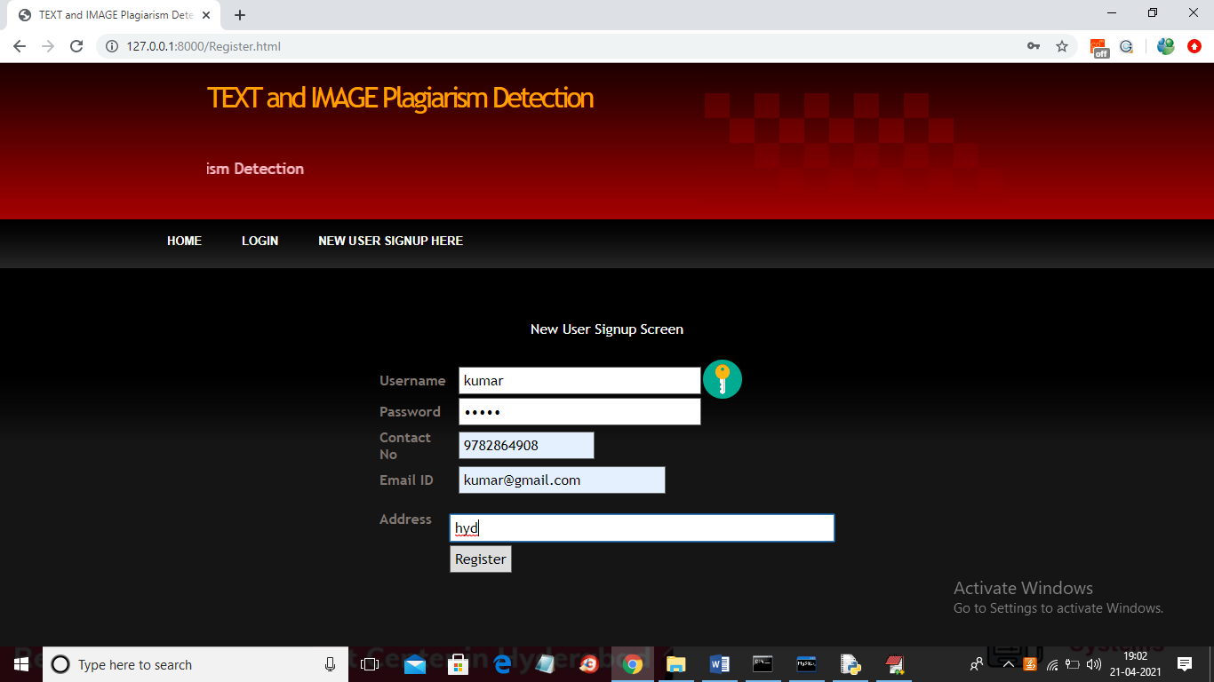
In above screen user signup details entered and then click on ‘Register’ button to get below screen
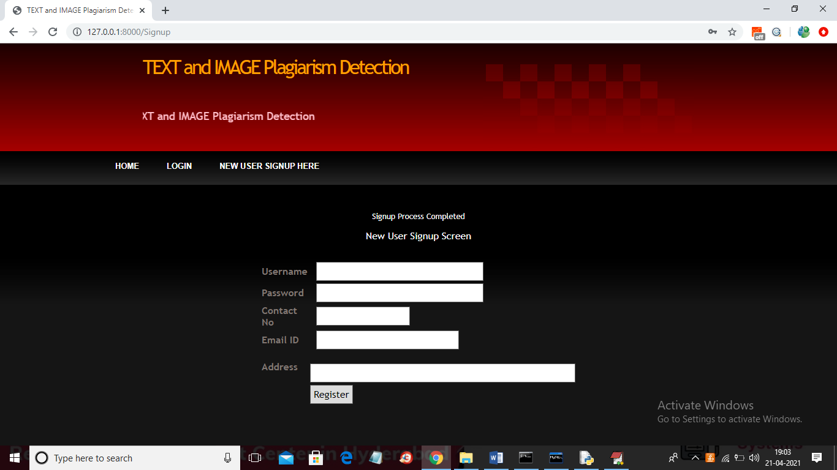
In above screen user signup process completed and now click on ‘Login’ link to get below screen
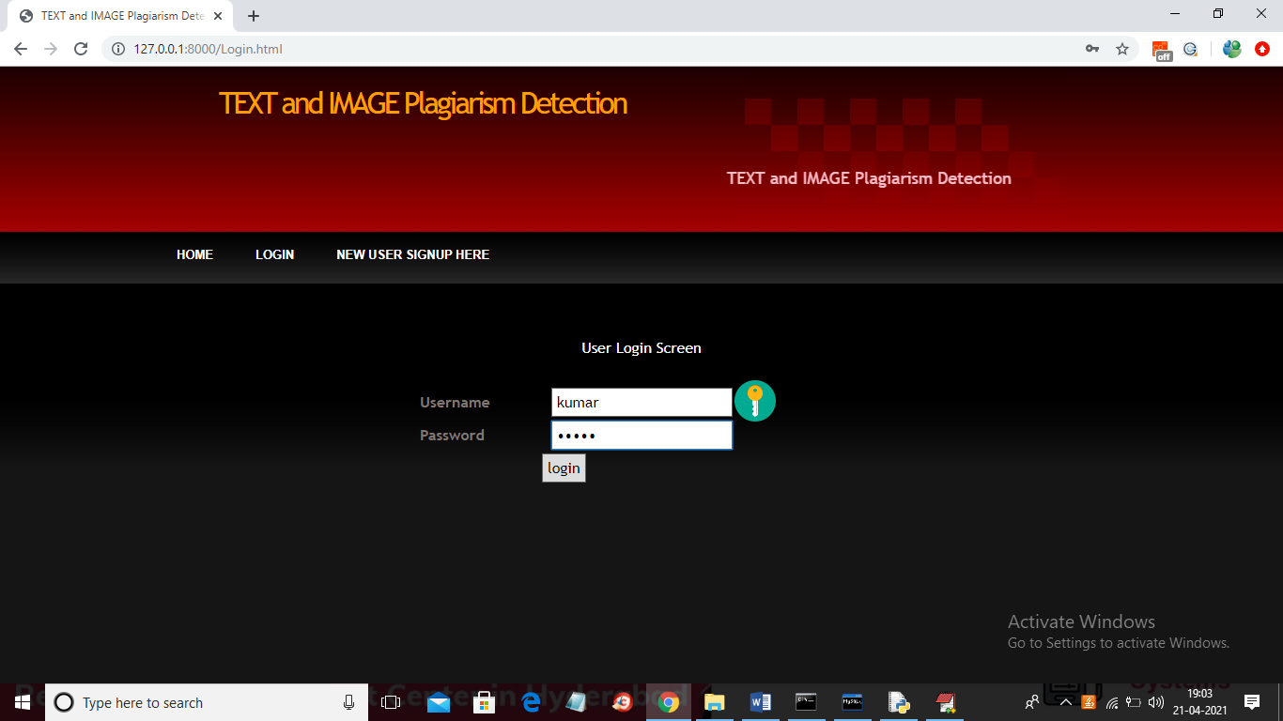
In above screen user is login and then click on button to get below screen
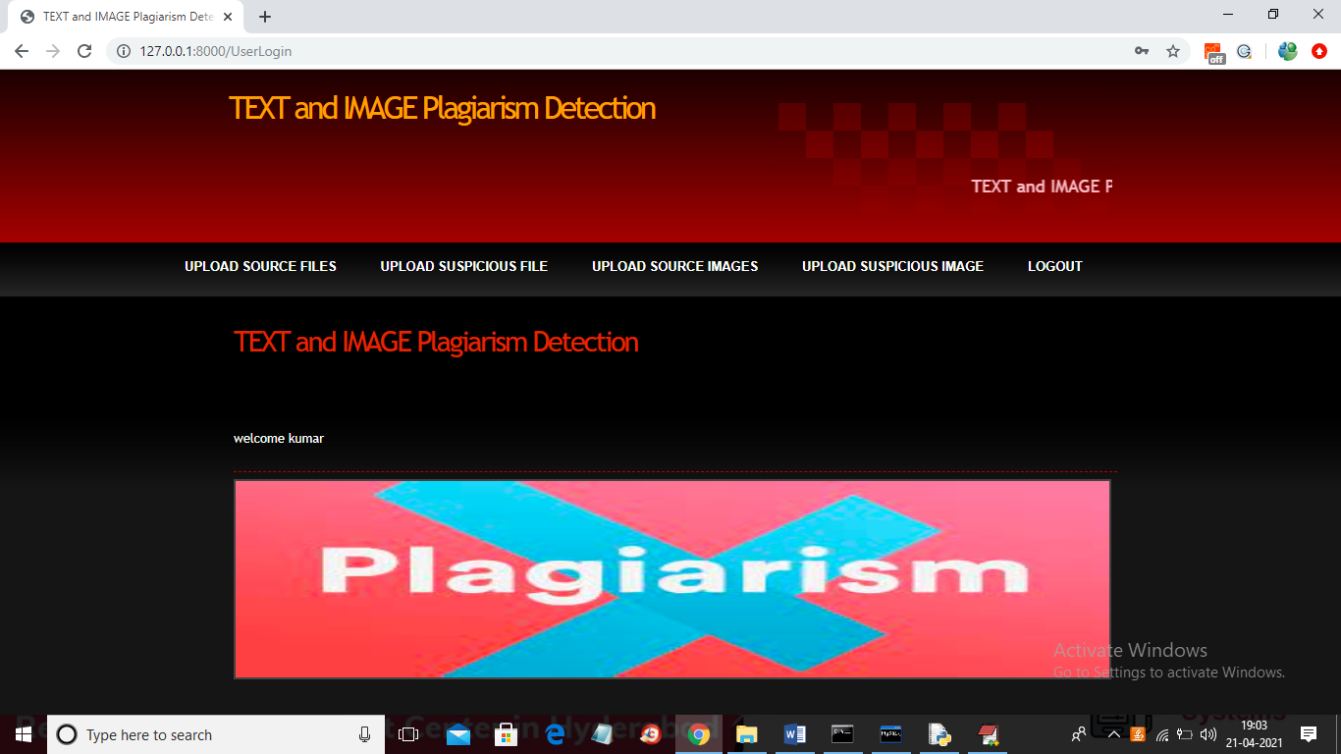
In above screen click on ‘Upload Source Files’ link to load all files from corpus folder
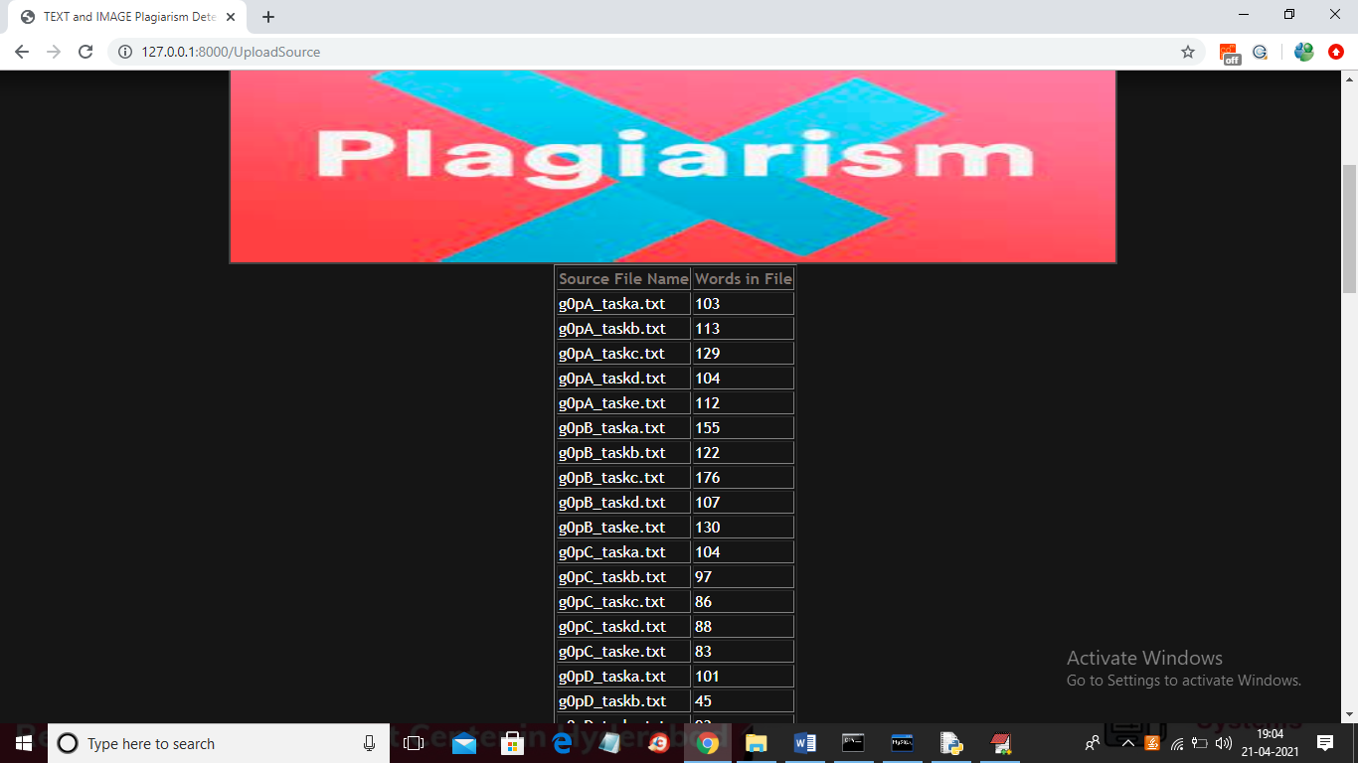
In above screen all files are loaded now click on ‘Upload Suspicious File’ button to load suspicious file and get result
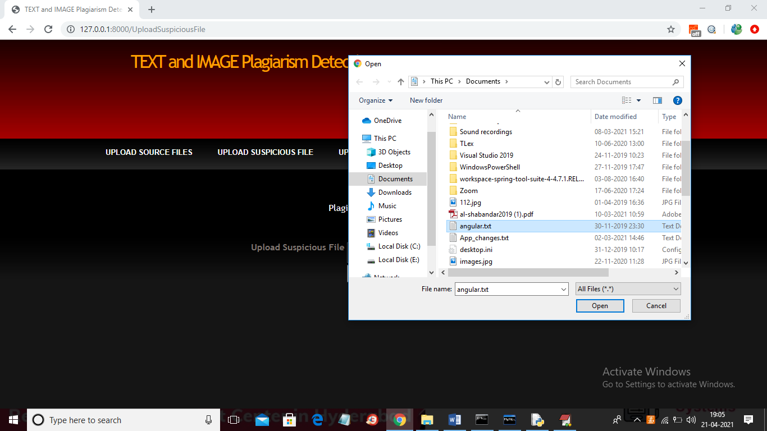
In above screen I am selecting and uploading ‘angular.txt’ file and then click on ‘Open’ button to get below result and then click on ‘Check Plagiarism’ button to get result
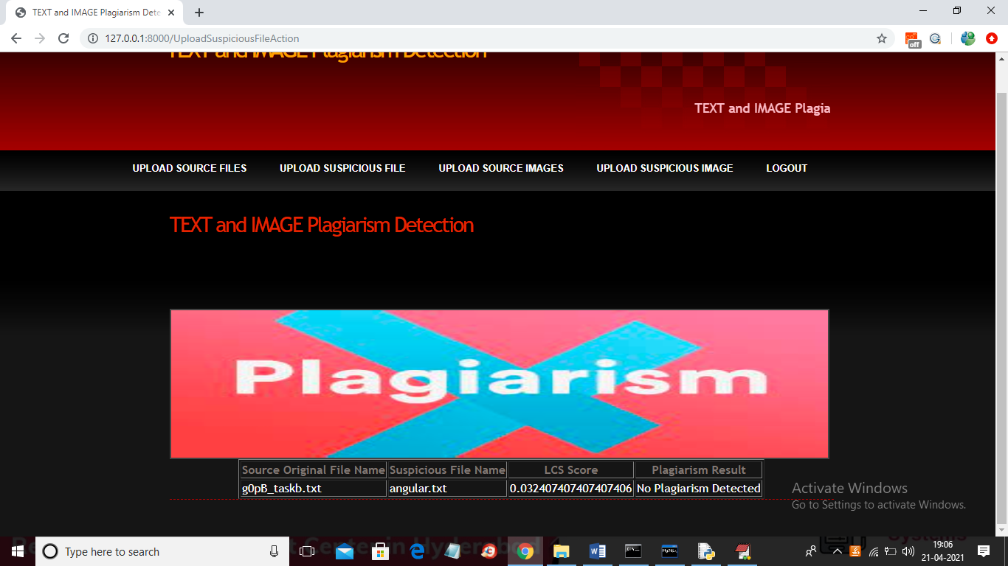
In above screen angular.txt file matched very little with g)pB_taskb.txt corpus file and we got similarity score as 0.03 so no plagiarism detected and now upload any file from corpus and see result
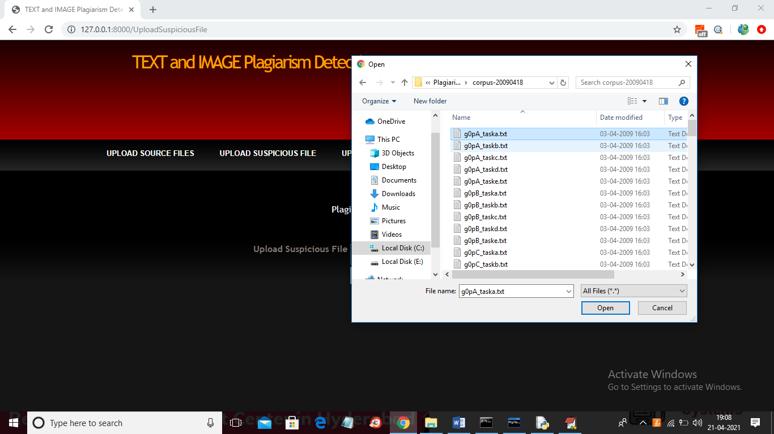
In above screen I am selecting and uploading first file and then click on button to get below result
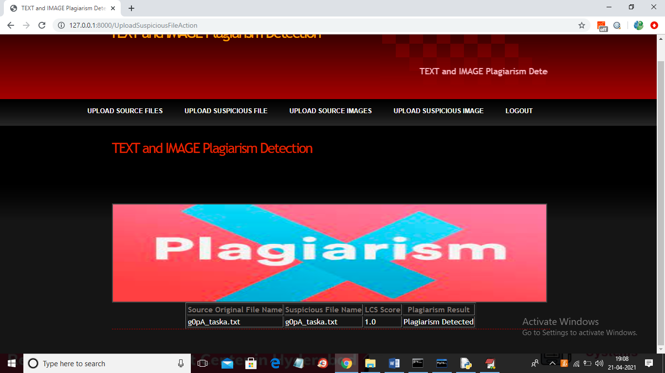
In above screen LCS score is 1.0 which means 100% matched with corpus file so plagiarism detected and similarly not only this u may enter any text file and get result. Now click on ‘Upload Source Images’ link to upload all images from ‘images’ folder
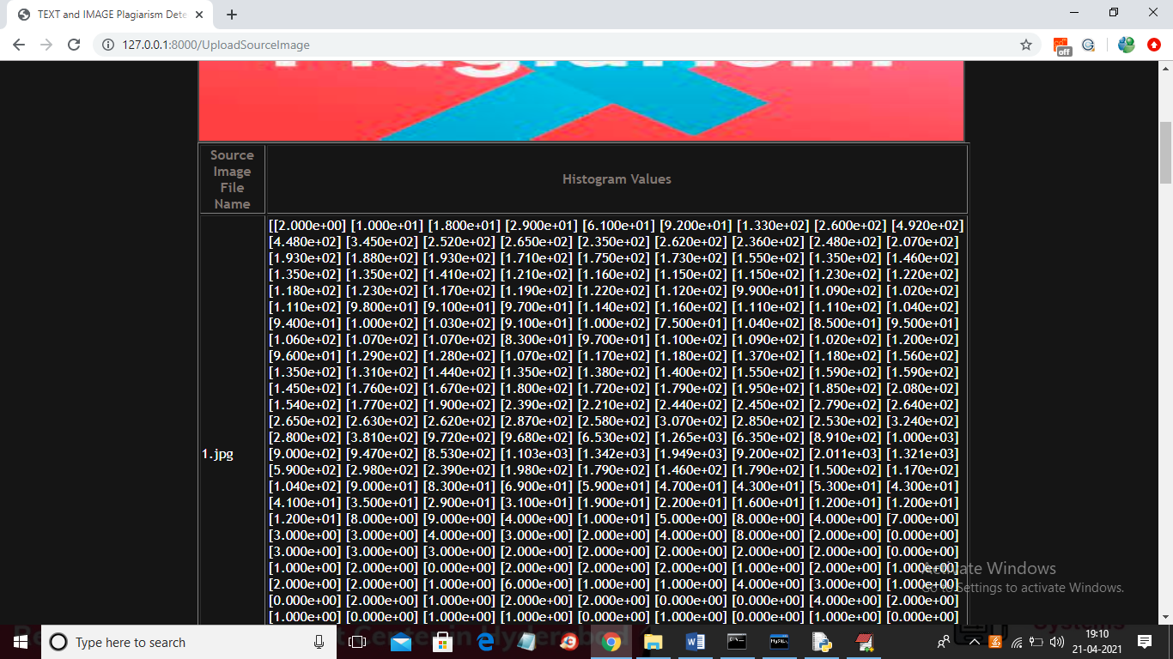
In above screen from all database images histogram will be calculated and store in array and whenever we upload new test image then both histogram will get matched and now click on ‘Upload Suspicious Image’ link to upload some image
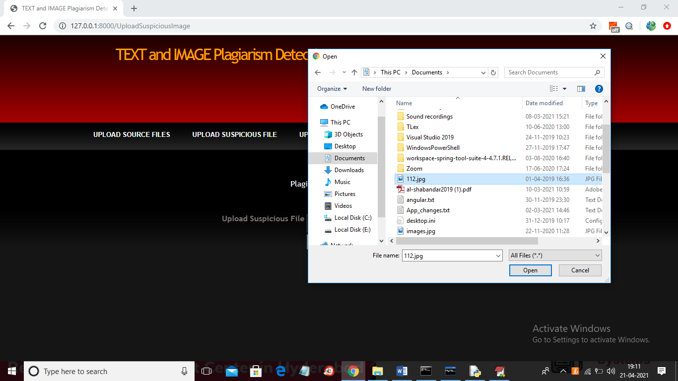
In above screen I am selecting and uploading ‘112.jpg’ file and then click on ‘Open’ button to get below result
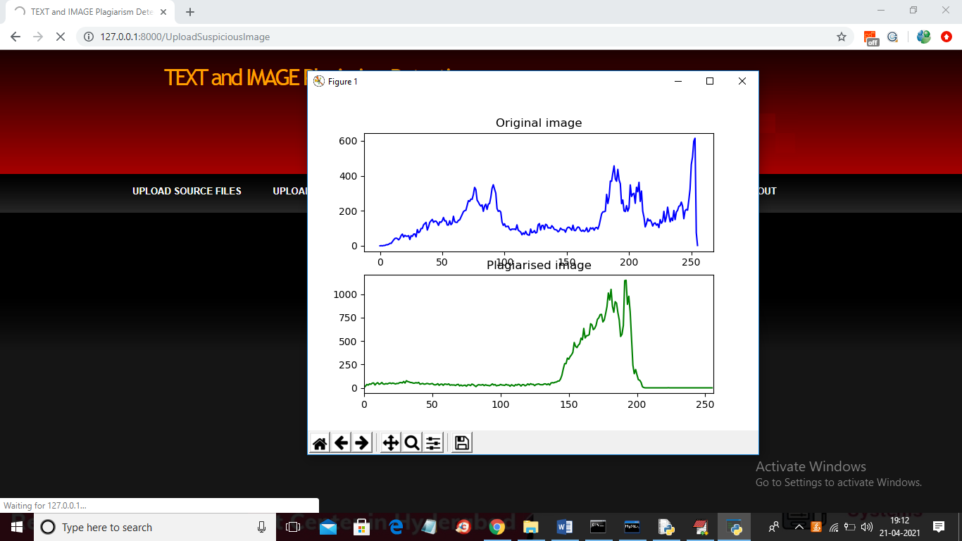
In above screen we can see for database image and uploaded image we generated histogram and we can see there is no match in histogram so no plagiarism will be detected and now close above graph to get below result
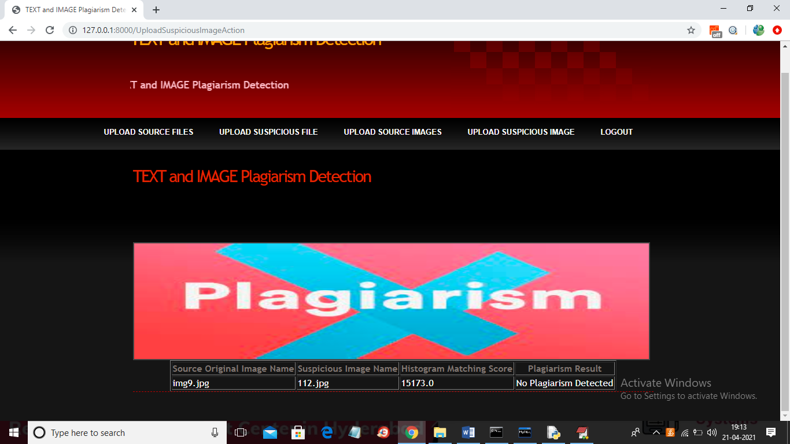
In above screen histogram pixel matching score is 15173 out of 40000 pixels so image is not plagiarised and now upload image from “images” folder and see result
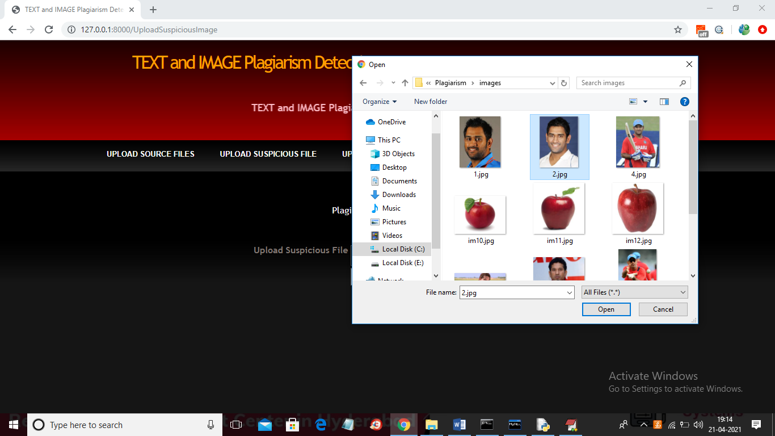
In above screen I am selecting and uploading ‘2.jpg’ file from “images” database folder and below is the result
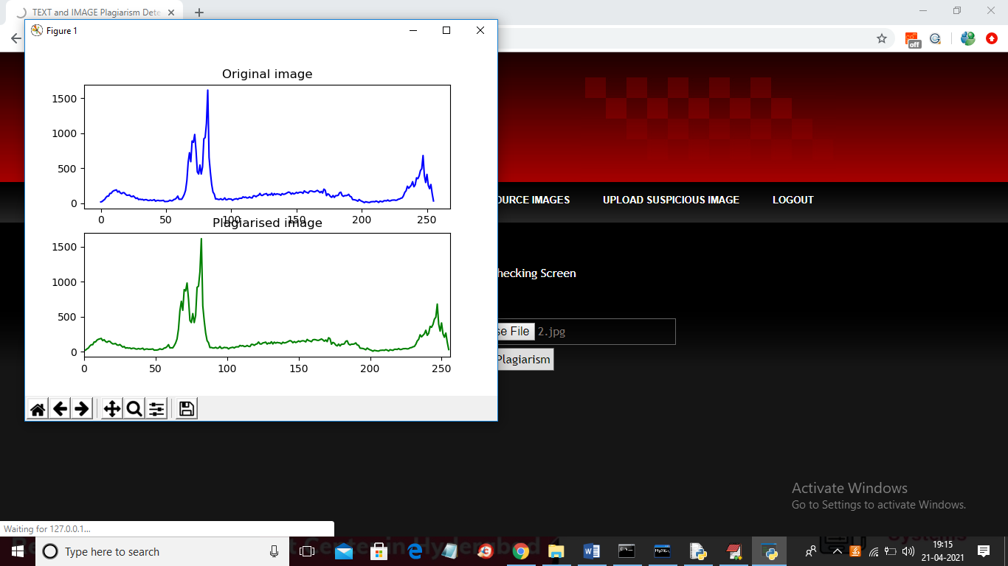
In above screen we can both original and uploaded image histogram is matching 100% so plagiarism is detected and now close above graph to get below result
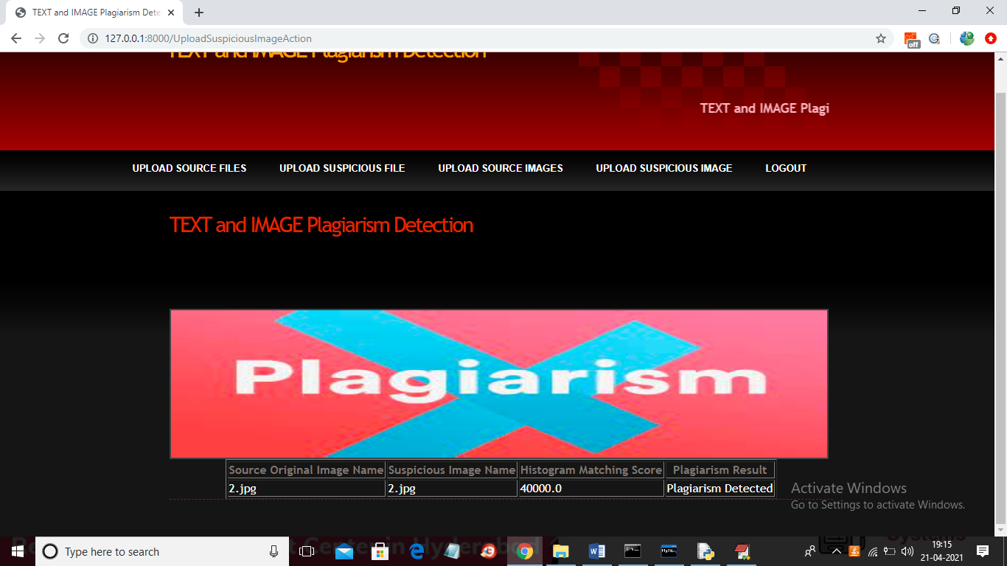
In above screen histogram matching score is 40000 which means all pixels matched so plagiarism is detected in above result.
Similarly u can upload any text file and image and test the application

